Brian Engel

CS-360 Project 3

For the description of my application, I would keep the actual description fairly simple and just establish what it does. This app allows you to track weight on a daily basis, establish a target weight, and notify you by SMS message when that weight is achieved. Then I would include a bunch of screenshots since that is what will sell the app. Afterall, a picture is worth a thousand words. The icon I would use would be the same png I have on the login screen, to create a sense of consistency and brand identity throughout the user experience.

Icon: 

Login: 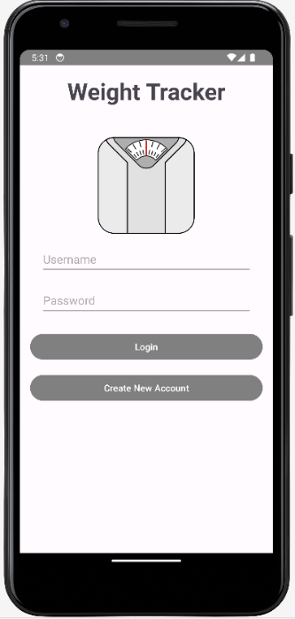

The Play Console Help has a ton of useful information on it, such as requirements for the version of Android that new and existing apps must run on. New apps must target Android 13 (API level 33) or higher; except for Wear OS apps, which must target Android 11 (API level 30) or up to Android 13 (API level 33). Existing apps must target API level 31 or above to remain available to users on devices running Android OS higher than your app's target API level. Apps that target API level 30 or below (target API level 29 or below for Wear OS), will only be available on devices running Android OS same or lower than your apps’ target API level. This all checks out fine for my app since the target SDK is 33. The minimum for my app is 24 which corresponds to Android 7.0 (Nougat). This means that it is able to run on 96.3% of devices.

There are two things included in the manifest that relate to permissions. The first is the <uses-permission android:name="android.permission.SEND_SMS" /> which is the permission to send SMS messages. The second is not really a permission, but lets the device know that it has the ability to use the telephone hardware: <uses-feature android:name="android.hardware.telephony" android:required="false" />. Required is set to false so it will show up in the Play Store for devices like tablets that may not have telephone hardware attached.

In all honesty I would never charge for this app because there are a thousand out there that are already free and have more features. No one would ever pay money out of pocket for it. My only hope would be to monetize through in-app ads. On this note one thing that I noticed in Play Console Help was that your app needs a content rating. Your content rating is based on who your target audience is and determines the type of advertising you can have. If your audience is 13 and under or family you are restricted to a requirement to only use Families Self-Certified Ads SDKs. This is why I would not market this as kid or family designed and just market toward adults, even though it isn’t inappropriate for children. This would keep all advertising options open. The only other way I could think of to monetize this application would be to keep improving the code and sell it as a base for other apps.